How to put web app code on Azure Web app :

Refer : <https://docs.microsoft.com/en-us/azure/app-service/app-service-deploy-ftp>

&

<https://docs.microsoft.com/en-us/azure/app-service/app-service-deployment-credentials>

1. Create an empty web on azure portal :

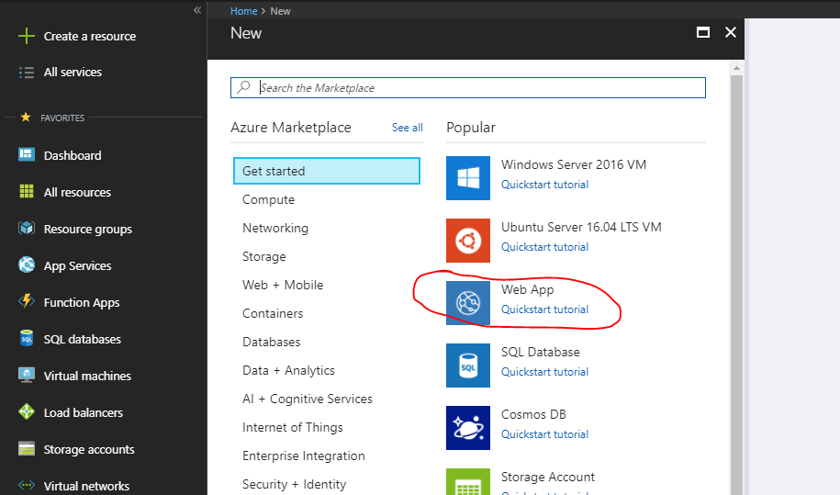

Note step number 2 to 5 is only user full if you have FileZilla software installed don your machine , if not then move to step 6 directly

1. Once the web app is created , go to deployment credentials options :

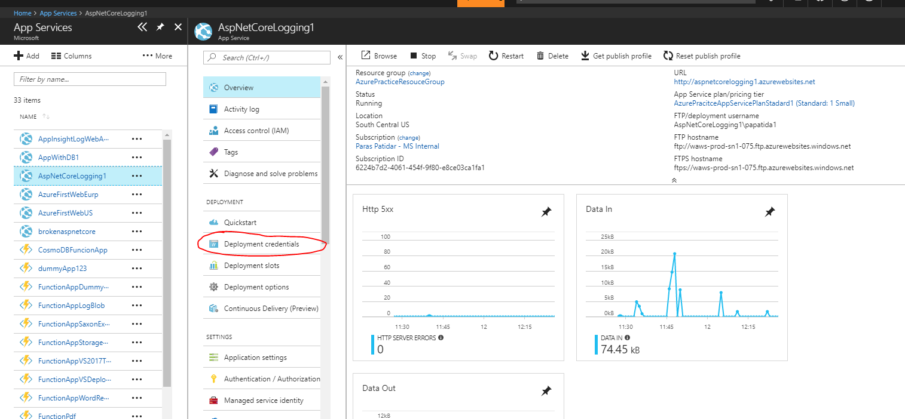

1. Set the user id and password for FTP deploye :

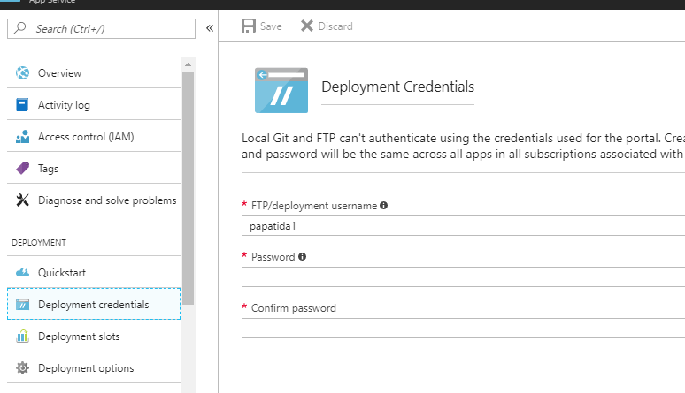

1. Go to overview option of that Web app :

Note the User name , which is like <webappname>\<username>

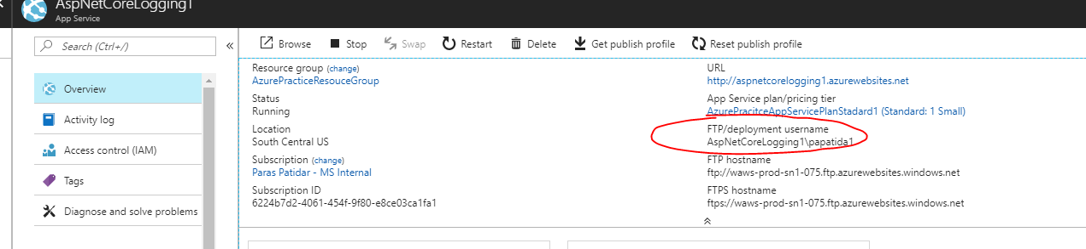

1. Note the FTP deployment address :

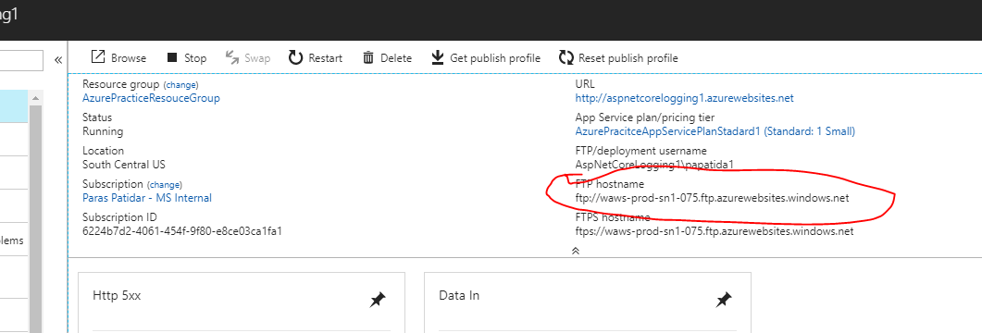

1. Now we have 2 ways to deployed it :
   1. KUDU
   2. FileZilla
2. Open the kudu console of web app from advance tool option , it will open a link for kudu of your web app

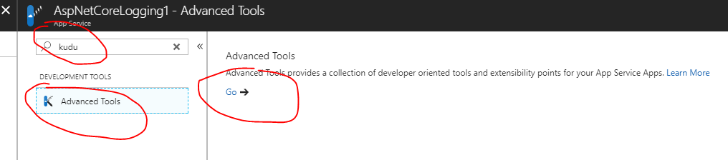

1. Go to debug console🡪 CMD

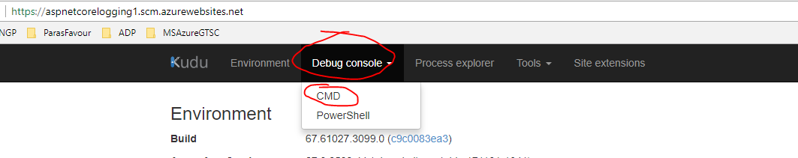

1. By default it has 3 folder , one of them is Log files , we shall create files over there
2. For FileZilla , pleas use the important fields in FileZilla UI :

**Host** : FTP host name from point number 5.

**Username** : Username from point number 4.

**Password** : password which we set in point number 3.

